Camille Howard

MSDS 6371 HW 2 4 Output

4A.

proc power;

twosamplemeans

meandiff = 1.92

stddev = 6.14

ntotal = .

power = .8;

plot x = effect min =.5 max = 2;

run;

**The POWER Procedure**

**Two-Sample t Test for Mean Difference**

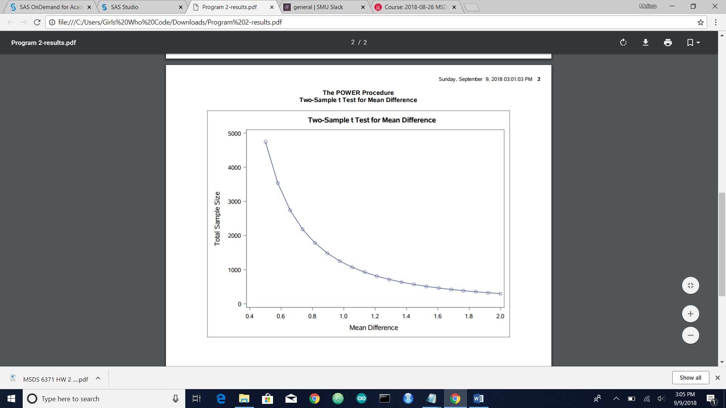

4B.

proc power;  
twosamplemeans  
meandiff = 1.92   
stddev = 6.14  
ntotal = .  
power = .8 .7 .6;  
plot x = effect min =.5 max = 2;  
run;

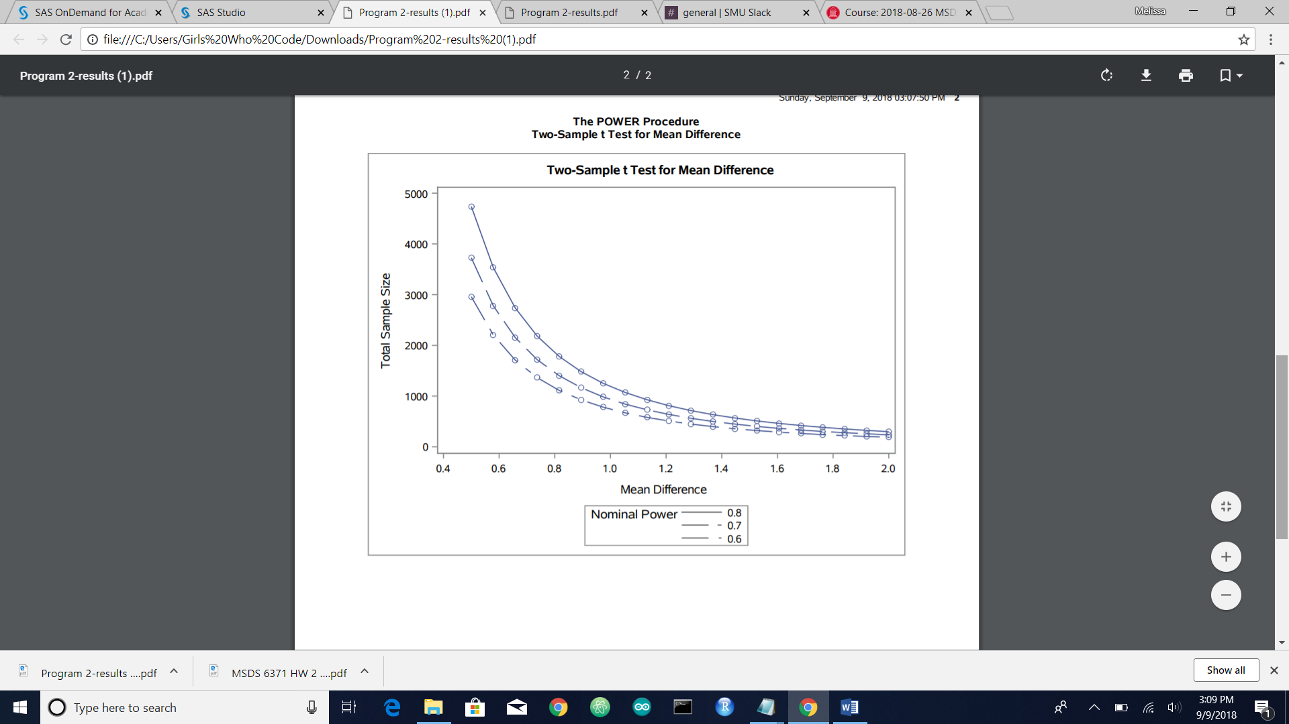

4C.

proc power;  
twosamplemeans  
meandiff = 1.92   
stddev = 6.14  
ntotal = .  
power = .80;  
plot x = effect min= .2 max = .8;  
run;

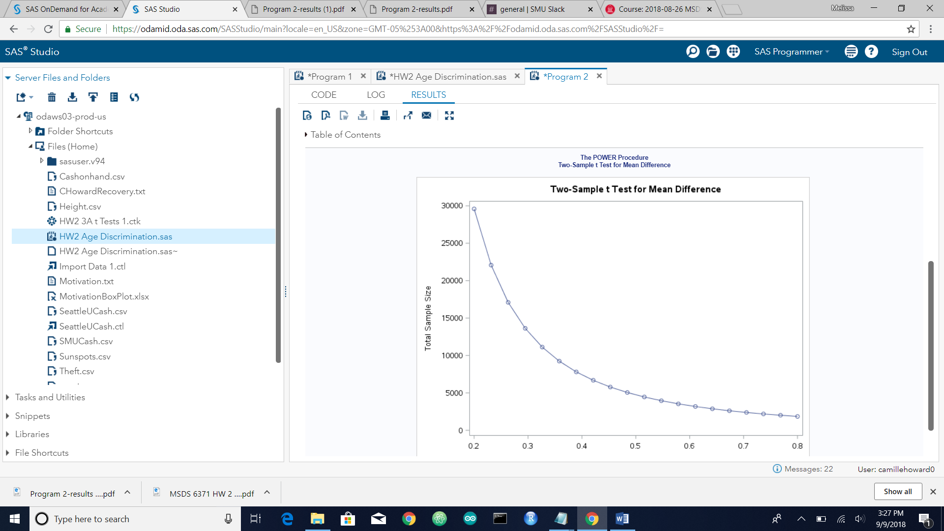

proc power;  
twosamplemeans  
meandiff = 1.92   
stddev = 6.14  
ntotal = .  
power = .60;  
plot x = effect min= .2 max = .8;  
run;

